**KEY REQUIREMENTS**

* Efficient filtering of candidates for developer profiles.
* Automated reliable scoring
* Customizability of tests
* Fluid UI
* Support for maximum number of languages

**USER STORIES**

* 2 user roles: Candidates and admin
* Candidate actions: Logs in, views a catalog of tests of available on his dashboard, joins the test he wants to take, answers the test in the exam console and submits. He may also view history of tests taken on his dashboard.
* Admin actions: Logs in, views dashboard of active and past tests, sets test using questions from a catalog or custom questions, publishes the test. When the test is complete, he can view the performance of all the candidates

**MODULES**

* Authorization module:

Login/sign up using email-password or using google, github login

* User dashboard module:

Contains a list of all active tests and history of tests taken. Clicking on past tests displays the candidate’s score and the questions of that test. Active tests have a button to enroll the candidate which redirects to the test answering module.

* Admin dashboard module:

Contains the list of active tests and history of previous tests. Clicking on a completed test displays the performance of all candidates who took the test. It has a button to create test which directs admin to the test creation module.

* Test creation module:

Has provisions to set the time limit, test name and position available, enable custom questions. Has a catalog of questions the admin can select from.

* Test answering module:

Has a syntax-highlighted code editor, sample test cases, language selector and output widget.

* Candidate performance module (candidate side):

Displays total scores and scores on each question.

* Candidate performance module (admin side):

Lists performance of all test takers and categorizes them. Provisions to filter by score and other parameters.

**TOOLS TO BE LEVERAGED:**

* Jdoodle compiler API

Online JSON based API service to compile and execute user code.

* Ace code editor plug-in

Embeddable code editor written in JavaScript

* Firebase

To help manage user accounts and data

**USE CASE DIAGRAM**

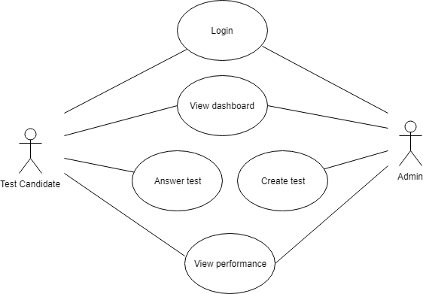

**SEQUENCE DIAGRAM**

**FLOW CHART**